Final Course Graduation Project
MSIS-822 Advanced Data Analytic Techniques

Detecting AI-Generated Arabic Academic Text Using Stylometric Features and Transformer-Based Models
2025
Student Name | Student ID
Amani Fahad Aloufi | 4725097
Asmaa Raja Allah Alharbi | 4725073
Ohud Sulaiman Alraddadi | 4725435
Dr. Mohammed Al-Sarem

Abstract
The increasing use of large language models has intensified concerns regarding the detection of AI-generated text, particularly in Arabic academic writing. This study investigates the task of identifying AI-generated Arabic abstracts using both stylometry-based machine learning models and deep learning techniques. A leakage-safe dataset of human-written and AI-generated Arabic academic abstracts was constructed and processed through a multi-phase pipeline involving preprocessing, exploratory analysis, stylometric feature extraction, and model training. Traditional classifiers, including Random Forest, were evaluated alongside a transformer-based model (Arabic BERT). Experimental results show that structural and stylistic features are highly informative, while Arabic BERT achieves the best overall performance. Error analysis indicates that highly standardized human writing and stylistically varied AI text remain challenging cases. These findings demonstrate the effectiveness and limitations of current AI-text detection approaches in Arabic.
Keywords: AI-generated text detection, Arabic NLP, stylometry, BERT, academic writing

1. Introduction
The rapid advancement of large language models has transformed the way text is produced, enabling the automatic generation of fluent and coherent content across multiple languages. While these technologies offer substantial benefits, their increasing use in academic contexts raises serious concerns related to authorship, originality, and academic integrity. The ability of generative models to produce text that closely resembles human writing has made it increasingly difficult to distinguish between human-authored and AI-generated content, particularly in formal academic writing where stylistic conventions are already highly standardized. These challenges are especially pronounced for the Arabic language, which remains underrepresented in AI-text detection research compared to English.
Recent studies have shown that traditional plagiarism detection tools are not well suited to identifying AI-generated text, as generated content is often original and does not rely on direct copying. This has motivated the development of AI-text detection systems that rely on linguistic, stylistic, and semantic cues rather than surface-level similarity. However, most existing approaches focus primarily on English datasets and do not fully account for the linguistic and morphological complexity of Arabic, including rich inflection, orthographic variation, and flexible syntactic structure.
The objective of this project is to design and evaluate an AI-text detection framework tailored to Arabic academic writing. Specifically, the project aims to (i) construct a leakage-safe dataset of human-written and AI-generated Arabic academic abstracts, (ii) explore the effectiveness of stylometric features capturing structural, lexical, morphosyntactic, and semantic characteristics of text, (iii) compare traditional machine learning classifiers with a deep learning transformer-based model (Arabic BERT), and (iv) analyze model behavior through feature importance and error analysis. By addressing these objectives, the project seeks to contribute empirical evidence on effective strategies for AI-generated text detection in Arabic and to highlight the limitations and challenges that remain in this rapidly evolving area.

2. Related Work
Research on AI-generated text detection has developed multiple methodological approaches aimed at discriminating machine-generated from human-authored texts. Early work in this area utilized stylometric and linguistic feature analysis, which relies on quantitative measures of textual style such as lexical choice, syntactic patterns, and sentence structure to differentiate output produced by large language models (LLMs) from human writing (O’Sullivan, 2025; Przystalski, 2025). Stylometric approaches exploit variations in writing style and have been applied in comparative studies of AI and human texts, demonstrating measurable distinctions in stylistic profiles (O’Sullivan, 2025).
A substantial body of work has explored machine learning classifiers that leverage handcrafted features extracted from text. Prova (2024) reviews techniques combining support vector machines, ensemble methods, and other traditional classifiers with engineered features to detect AI-generated content, noting that these methods can serve as effective baselines for classification tasks. Research also emphasizes that reliability remains a challenge, as many detectors struggle under obfuscation or paraphrasing conditions (Weber-Wulff et al., 2023).
The advent of deep learning-based detectors has further advanced the field. Transformer-based architectures such as BERT and variants have been employed to capture richer contextual and semantic representations of text. Experimental results indicate that deep learning models often outperform traditional methods in classification accuracy when trained on labeled datasets of human and AI-generated text (Wang et al., 2024; Mo et al., 2024). These models benefit from large pretrained language models’ ability to encode complex linguistic patterns, although they also require substantial training data and computational resources.
Recent surveys provide comprehensive overviews of detection techniques, categorizing existing methods into feature-based, neural-based, hybrid, and watermarking approaches. These reviews highlight emerging trends and limitations in current systems, such as bias in detection performance and the impact of adversarial text transformation on model efficacy (Fariello, 2025; Kehkashan, 2025). They also underscore the importance of developing generalized detection frameworks capable of adapting to evolving LLM outputs.
Despite progress, empirical evaluations report that existing AI detection tools exhibit varying degrees of accuracy and reliability, with some commercial and academic systems achieving moderate performance yet showing susceptibility to contextual shifts and stylistic variability (ResearchGate, 2025; Brandeis University AI Council, 2025). Such findings suggest ongoing challenges in developing robust, domain-agnostic detectors, particularly for under-researched languages and contexts.

3. Dataset

3.1 Dataset Description
This project uses the KFUPM-JRCAI Arabic Generated Abstracts dataset; a publicly available benchmark designed for research on AI-generated Arabic text detection. The dataset consists of Arabic research-paper abstracts written by humans and corresponding AI-generated versions produced by multiple large language models, making it well suited for binary classification tasks.

3.2 Dataset Source and Structure
The dataset was obtained from the Hugging Face Hub (KFUPM-JRCAI/arabic-generated-abstracts) and is organized into three subsets based on text generation strategy:
- by_polishing: AI-generated texts created by refining existing human abstracts
- from_title: Abstracts generated using only the paper title
- from_title_and_content: Abstracts generated using both title and content
Each subset includes one human-written abstract and four AI-generated versions produced by Allam, JAIS, LLaMA, and OpenAI models.

3.3 Data Transformation, Labeling and Cleaning
All subsets were reshaped into a single dataset for binary classification, where each abstract is treated as an independent sample. Each record contains the text content, a binary label (0 for human, 1 for AI-generated), the source model, and basic metadata such as text length. The resulting long-format dataset initially contained 41,940 samples. Class distribution analysis revealed a strong imbalance favoring AI-generated text with approximately 20% human-written texts (8,388 samples) and 80% AI-generated texts (33,552 samples). Duplicate analysis identified repeated human abstracts across splits; a small number of duplicated records were removed, yielding a final dataset of 41,936 unique samples.

4. Methodology
This project follows a phased data-mining methodology aligned with the MSIS-822 project framework. Each phase corresponds directly to an implemented Jupyter notebook, ensuring traceability between methodological design, code execution, and reported results.

4.1 Text Preprocessing and Exploratory Data Analysis
The objective of this phase is to prepare Arabic text data for modeling through systematic preprocessing and to perform exploratory data analysis (EDA) to identify linguistic patterns and structural differences between human-written and AI-generated abstracts.
4.1.1 Arabic Text Preprocessing
The long-format dataset produced during dataset preparation was loaded and subjected to a preprocessing pipeline specifically designed for Arabic text. Initial normalization steps were applied to reduce orthographic variation and stylistic noise. These steps included unifying character variants (e.g., Alef and Yeh forms), removing diacritics (Tashkeel), punctuation, digits, and non-Arabic symbols. Elongated characters were normalized to their base forms to mitigate stylistic exaggeration commonly introduced by generative models.
Tokenization and linguistic preprocessing were performed using Arabic NLP utilities. Stopword removal was applied to retain semantically meaningful content, and light stemming was used to reduce words to their morphological roots while preserving contextual information. The resulting cleaned text was stored as a separate representation and retained alongside the original text to support both stylometric feature extraction and neural modeling in later phases.
4.1.2 Exploratory Data Analysis (EDA)
Exploratory analysis was conducted to compare human-written and AI-generated abstracts at both structural and lexical levels. Text length statistics, including character counts and token counts, were analyzed to assess verbosity and content density across classes.
Structural Characteristics and Length Analysis
Document-level statistics were further analyzed to compare average text length across different generation sources (Allam, JAIS, LLaMA, OpenAI) and human authorship. Figure 4.1 shows the average number of words per document grouped by generation method and data split.
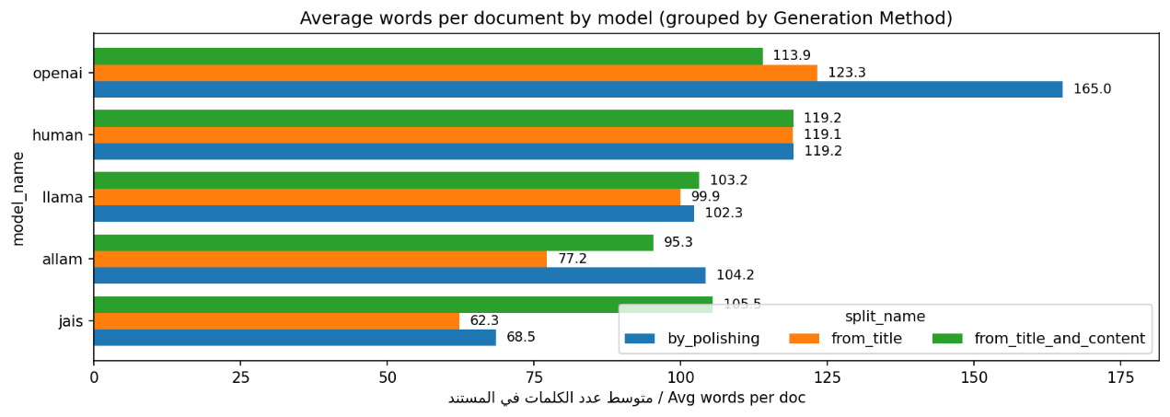
Figure 4.1. Average number of words per document by generation method.
The figure reveals stylistic differences across AI models, with some generators producing longer and more uniform abstracts compared to human writing.
Lexical and Phrase-Level Analysis
To complement frequency analysis, word cloud visualizations were generated for each class. As shown in Figure 4.2, AI-generated text emphasizes a narrower set of recurring academic terms, while human text displays a more diverse vocabulary distribution.
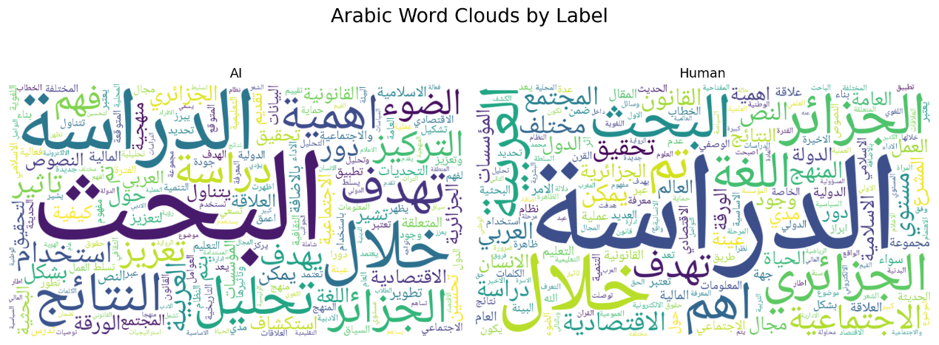
Figure 4.2. Arabic word clouds by label (AI vs. Human).
Word size corresponds to frequency, illustrating differences in lexical concentration and diversity.
To examine lexical usage patterns, n-gram frequency analysis was performed separately for AI-generated and human-written text. Figure 4.3 presents the most frequent unigrams, bigrams, and trigrams for each class. AI-generated abstracts exhibit a higher concentration of generic academic phrases and repeated expressions, whereas human-written abstracts demonstrate greater lexical dispersion and more varied phrase construction.

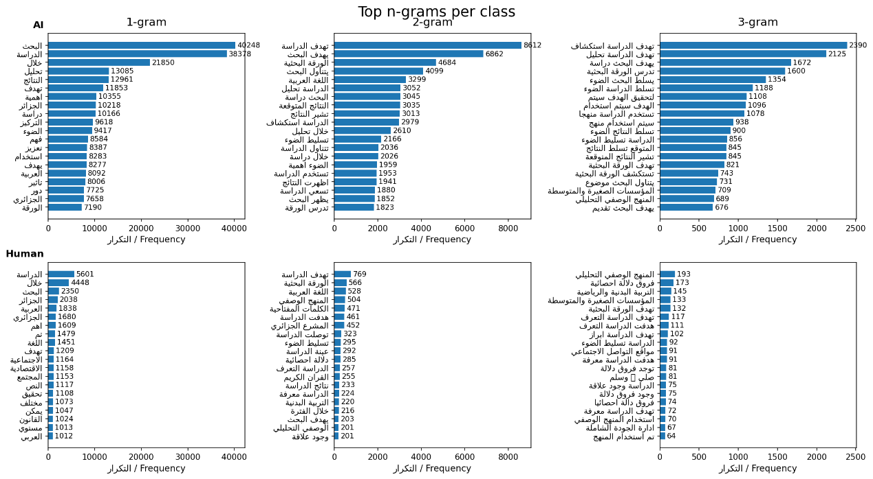
Figure 4.3. Top n-grams per class (1-gram, 2-gram, and 3-gram) for AI-generated and human-written text.
The figure highlights systematic repetition in AI text compared to broader lexical variety in human abstracts.
Comparative Summary of Linguistic Tendencies
To synthesize the observed patterns, Table 4.1 summarizes key stylistic differences between AI-generated and human-written text identified during EDA.
Table 4.1. Comparative linguistic tendencies observed during exploratory analysis
Feature | AI tendency | Human tendency | Possible explanation
Sentence length | Shorter, more uniform | Longer, clause-heavy | AI favors regular structure; humans vary syntax
Vocabulary richness | More repetitive | More diverse | Humans vary phrasing and topics
Word length | Slightly longer | Slightly shorter | AI favors formal and derived words
Function words & punctuation | Largely similar | Largely similar | Both are grammatically well-formed

Overall, the exploratory analysis indicates that AI-generated text is stylistically controlled and uniform, characterized by shorter sentences, lower sentence-length variance, and higher lexical repetition. In contrast, human-written abstracts exhibit greater syntactic flexibility and lexical diversity, reflecting more varied expressive choices. These findings directly motivated the selection of structural, lexical, and semantic features used in subsequent stylometric modeling phases.

4.2 Stylometric and Linguistic Feature Engineering
This phase constructs the feature representations used for supervised classification. The cleaned dataset from Phase 2 was partitioned into training (70%), validation (15%), and test (15%) splits using a fixed random seed (SEED = 42) with label stratification. The split was performed before feature extraction to prevent information leakage, and each document was tagged with its split identifier.
Arabic-specific preprocessing utilities ensured consistent sentence segmentation and tokenization. Sentence boundaries were detected using punctuation-aware regular expressions, while tokenization retained Arabic tokens based on Unicode properties. Morphosyntactic analysis was performed using the CAMeL Tools MLE Disambiguator, producing token-level annotations such as part of speech, grammatical case, number, and voice.
Document-level features were then extracted, grouped as follows:
- Structural features: total character count, whitespace-to-character ratio, total sentence count, sentence-length variance, and single-quote frequency.
- Lexical features: hapax legomena ratio and Shannon entropy of word-frequency distributions.
- Morphosyntactic features (CAMeL-based): counts of nouns and adverbs, noun-to-verb ratio, nominative-case count, singular-word count, and passive sentence count.
- Orthographic indicators: tanween frequency and hyperlink count.
- Embedding-based similarity features:
(i) average cosine similarity between adjacent sentence embeddings using arabic-arabert-all-nli-triplet (capped at 12 sentences per document);
(ii) average cosine similarity between adjacent token embeddings using AraBERT (aubmindlab/bert-base-arabertv02), with inputs truncated to 400 characters (maximum 256 subword tokens).
Feature extraction was executed in batches of 2,000 documents with checkpointing for scalability. Feature matrices were saved separately for the training, validation, and test splits, as well as in a combined file with split annotations. These structured feature tables form the inputs for model training in Phase 4.

4.3 Model Building, Training, and Evaluation
Phase 4 evaluates multiple classification models to distinguish between human-written and AI-generated Arabic text. Two modeling strategies were explored: classifiers trained on engineered stylometric features and deep learning models trained directly on raw text.
4.3.1 Baseline Models
A Logistic Regression classifier was used as the primary baseline, providing a strong linear reference on the engineered feature set. A Gaussian Naïve Bayes model was also evaluated during validation but excluded from final testing due to inferior performance.
4.3.2 Traditional Machine Learning Models
The following traditional classifiers were trained on the stylometric features:
- Linear Support Vector Machine (LinearSVC)
- Random Forest (RF)
- Extreme Gradient Boosting (XGBoost)
Hyperparameters were tuned using the validation split. RF and XGBoost effectively captured non-linear feature interactions, while LinearSVC provided a margin-based linear comparison.
4.3.3 Deep Learning Models
Two deep learning approaches were evaluated:
- Multi-Layer Perceptron (MLP): trained on engineered numeric features to model higher-order interactions.
- Fine-Tuned Arabic BERT: AraBERT (aubmindlab/bert-base-arabertv02) fine-tuned end-to-end on raw text using the Hugging Face Trainer framework.

4.3.4 Evaluation and Model Selection
Due to class imbalance (approximately 1:4 human-to-AI), performance was assessed using macro-averaged metrics: Accuracy, Precision, Recall, F1-score, and ROC–AUC. Confusion matrices were analyzed for class-specific error patterns. The best-performing models from each category were selected based on validation results and compared on the held-out test set.

5. Results and Analysis
This section reports the experimental results obtained on the held-out test set and provides an analytical comparison of baseline, traditional machine learning, and deep learning approaches for Arabic AI-text detection. Performance is evaluated using macro-averaged metrics to account for class imbalance, followed by interpretability and error analyses.

5.1 Overall Model Performance
Table 5.1 presents the test-set performance of representative models from each category.
Table 5.1. Test Set Performance Comparison
Model | Accuracy | Precision (Macro) | Recall (Macro) | F1-score (Macro) | ROC–AUC
Logistic Regression (Baseline) | 0.9582 | 0.9493 | 0.9175 | 0.9323 | 0.9771
Random Forest | 0.9852 | 0.9729 | 0.9815 | 0.9771 | 0.9975
MLP (Engineered Features) | 0.9660 | 0.9473 | 0.9462 | 0.9468 | 0.9900
Fine-tuned Arabic BERT | 0.9857 | 0.9819 | 0.9732 | 0.9774 | 0.9982
Both Random Forest and fine-tuned Arabic BERT achieve near-ceiling performance, with macro F1-scores above 0.97 and ROC–AUC values approaching 1.0. This indicates that both stylometry-driven ensembles and contextual transformer models are highly effective for this task.
5.1.1 Baseline Model
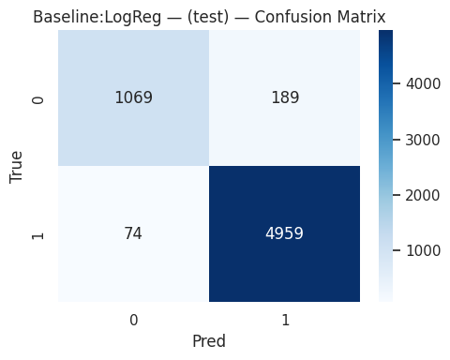
The Logistic Regression baseline performs strongly (F1 = 0.93), demonstrating that the engineered stylometric features are highly discriminative. However, its lower recall for the minority class (human-written text) reveals limitations in capturing more nuanced stylistic variation.
Figure 5.1. Baseline Logistic Regression Confusion Matrix (Test Set).
The baseline exhibits increased false positives for human-written abstracts, reflecting sensitivity to stylistic regularity.
5.1.2 Traditional Machine Learning Models
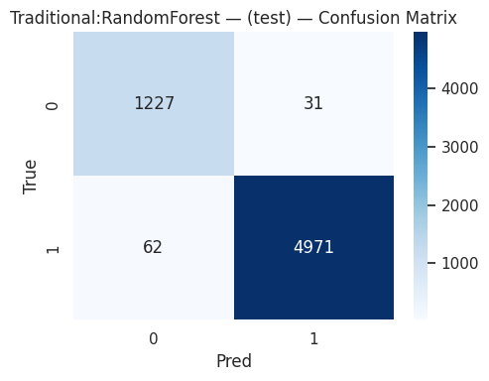
Among traditional models, Random Forest achieves the best overall performance. Its non-linear structure effectively captures interactions between structural, lexical, and embedding-based features, leading to high macro recall and robustness to class imbalance.
Figure 5.2. Random Forest Confusion Matrix (Test Set).
Random Forest substantially reduces misclassification of human-written text compared to the baseline.
5.1.3 Deep Learning Models
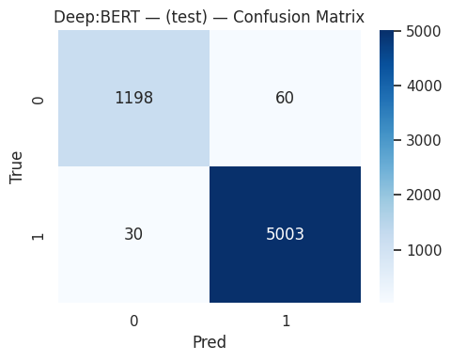
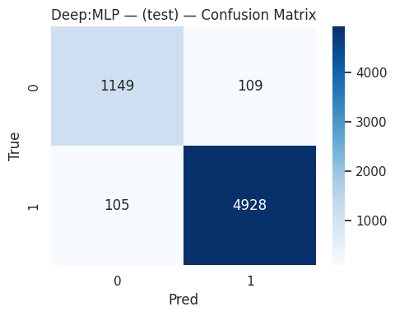
The MLP improves upon the baseline but does not surpass Random Forest, suggesting limited benefit from deeper architectures when operating on low-dimensional engineered features. In contrast, fine-tuned Arabic BERT achieves the highest ROC–AUC and macro F1, benefiting from deep contextual representations learned directly from raw text.
Figure 5.3. Deep Learning Confusion Matrices (MLP and BERT, Test Set).
BERT exhibits the lowest overall error rate, particularly reducing false negatives for AI-generated text.

5.2 Feature Importance Analysis (Random Forest)
To interpret the strongest traditional model, feature importance was analyzed using both impurity-based scores and permutation importance (Macro-F1).
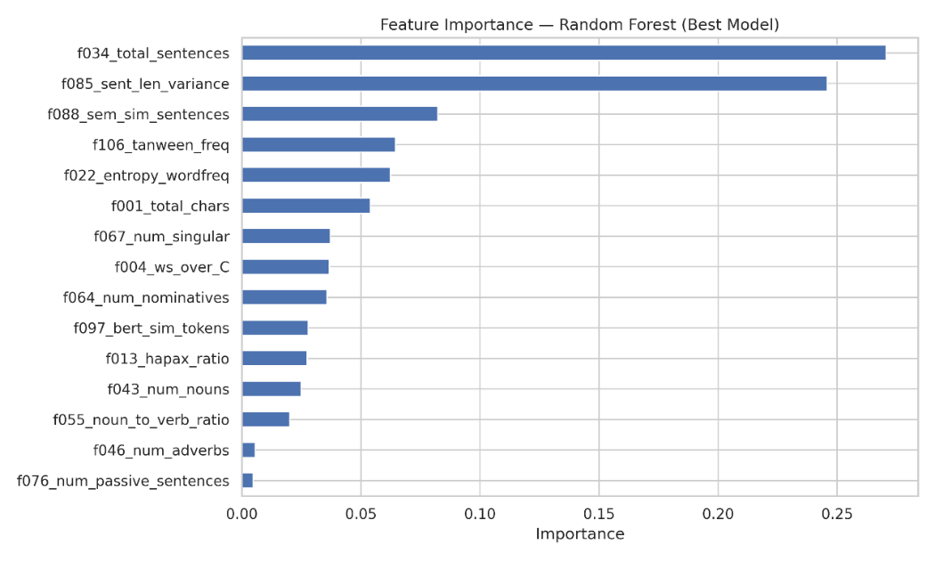
Figure 5.4. Random Forest Impurity-Based Feature Importance.
Structural features—total number of sentences (f034) and sentence-length variance (f085)—dominate model decisions.
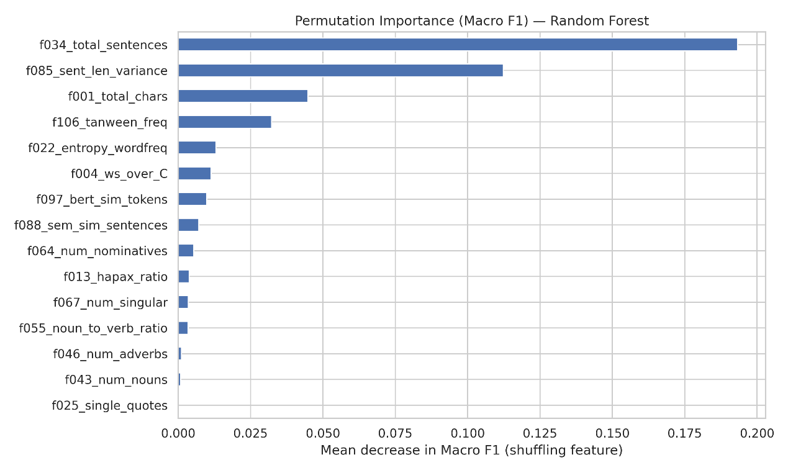
Figure 5.5. Permutation Importance on Test Set (Macro-F1).
Permuting sentence count and sentence-length variance causes the largest drops in performance, confirming their central role.
Both analyses consistently identify document-level structure as the most informative signal. Semantic smoothness (sentence-level embedding similarity), tanween frequency, and lexical entropy contribute moderately, while fine-grained syntactic counts (e.g., passive sentences, adverbs) have minimal impact.
To assess directionality, class-wise feature means were compared.
Table 5.2. Directionality of Top Features (AI Mean − Human Mean)
Feature | Human (0) | AI (1) | AI − Human
Total sentences | 2.692 | 4.826 | +2.135
Tanween frequency | 0.447 | 1.784 | +1.337
Sentence semantic similarity | 0.441 | 0.595 | +0.154
Sentence-length variance | 300.738 | 26.614 | −274.124
Total characters | 738.328 | 653.821 | −84.508
AI-generated abstracts tend to contain more sentences with smoother transitions, while human-written texts exhibit greater sentence-length variability, longer documents, and higher lexical diversity. This confirms that Random Forest relies primarily on high-level stylistic regularity rather than deep syntactic cues.

5.3 Error Analysis (Best Model: Deep BERT)
Following leakage-safe selection, Deep BERT achieved the highest test-set F1 and was used for error analysis.
Error Distribution.
Out of all test samples, 90 were misclassified: 60 false positives (Human → AI) and 30 false negatives (AI → Human). This indicates a mild bias toward predicting the AI class.
Qualitative Patterns.
False positives often correspond to highly standardized academic abstracts with formulaic structure and rigid rhetorical sequencing, which resemble generated text. False negatives frequently involve AI-generated samples that display greater topical specificity and stylistic variation, making them more human-like.
Interpretation.
Although BERT operates on raw text rather than engineered features, its errors mirror the stylometric findings: both approaches are sensitive to stylistic regularity and uniformity. Highly conventional human writing is therefore more likely to be flagged as AI.
Implications.
These findings highlight a key limitation of AI-text detection in academic domains: stylistic conventions can blur the boundary between human and generated text. Mitigating false positives may require incorporating discourse-level signals, calibration strategies, or domain-aware evaluation thresholds.

6. Conclusion and Future Work
Conclusion
This project addressed the detection of AI-generated Arabic academic text through a comparative study of stylometric feature engineering, traditional machine learning, and transformer-based deep learning. Using a carefully curated, leakage-safe dataset, the methodology spanned data acquisition, Arabic-specific preprocessing, exploratory analysis, stylometric and linguistic feature extraction, and rigorous model evaluation.
The results demonstrate that both stylometry-based and deep learning models are highly effective, albeit in different ways. Among traditional approaches, Random Forest achieved strong and interpretable performance by exploiting high-level structural and stylistic cues, with feature importance analysis identifying sentence count and sentence-length variance as the most discriminative signals. These findings confirm that AI-generated text tends to exhibit more uniform structural patterns than human-authored academic writing.
Across all models, fine-tuned Arabic BERT achieved the best overall test performance, indicating that contextual representations learned from large Arabic corpora capture subtle linguistic regularities beyond manually engineered features. Error analysis revealed that most misclassifications occur in stylistically ambiguous cases: highly standardized human abstracts were sometimes flagged as AI, while AI-generated texts with greater variability were occasionally classified as human. This underscores both the effectiveness of the proposed approach and the intrinsic difficulty of AI-text detection in academic domains.
Project Limitations
Despite strong results, several limitations remain. First, the dataset is limited to academic abstracts, which constrains generalization to other genres such as news, social media, or creative writing. Second, AI-generated samples were produced by a finite set of models, potentially biasing classifiers toward specific generation styles. Third, while Deep BERT provides superior accuracy, its limited interpretability poses challenges for explainability compared to stylometry-based models. Finally, the study adopts a binary classification setting and does not address hybrid or human-edited AI text, which is increasingly prevalent in real-world scenarios.
Future Work
Future research can extend this work in several directions. Expanding the dataset to include multiple genres and domains would improve robustness and generalizability. Incorporating outputs from a wider range of generative models and prompt configurations could mitigate model-specific bias. Hybrid approaches that combine stylometric features with deep contextual embeddings may offer a balance between interpretability and performance. Additionally, threshold calibration and cost-sensitive learning could be explored to reduce false positives in high-stakes applications. Finally, extending the task beyond binary classification to detect partially AI-assisted or edited text represents a critical and realistic direction for future investigation.

References
- Brandeis University AI Council. (2025). Limitations of AI detection tools. Retrieved from https://www.brandeis.edu/ai-steering-council/ai-literacy/ai-teaching-learning/detection-tools.html (Brandeis University)
- Fariello, S. (2025). A review of advances and challenges in AI-generated text detection. International Journal of Intelligent Machines and Internet of Things. (Revistas UNIR)
- Kehkashan, T. (2025). AI-generated text detection: A comprehensive review. ScienceDirect. (ScienceDirect)
- Mo, Y., Qin, H., Dong, Y., Zhu, Z., & Li, Z. (2024). LLM AI text generation detection based on transformer deep learning algorithm. arXiv. (arXiv)
- O’Sullivan, J. (2025). Stylometric comparisons of human versus AI-generated texts. Humanities and Social Sciences Communications. (Nature)
- Przystalski, K. (2025). Stylometry recognizes human and LLM-generated texts. arXiv. (arXiv)
- Prova, N. (2024). Detecting AI generated text based on NLP and machine learning approaches. arXiv. (arXiv)
- ResearchGate. (2025). Accuracy and reliability of AI-generated text detection tools: A literature review. Retrieved from https://www.researchgate.net/publication/389114020_Accuracy_and_Reliability_of_AI-Generated_Text_Detection_Tools_A_Literature_Review (ResearchGate)
- Wang, H., Li, J., & Li, Z. (2024). AI-generated text detection and classification based on BERT deep learning algorithm. arXiv. (arXiv)
- Weber-Wulff, D., Anohina-Naumeca, A., Bjelobaba, S., Foltýnek, T., Guerrero-Dib, J., Popoola, O., ... & Waddington, L. (2023). Testing of detection tools for AI-generated text. arXiv. (arXiv)

